Task 1:

pwd

ls –a –l

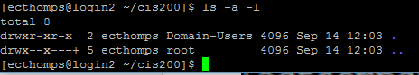

Task 2:

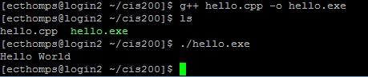

Task 3:

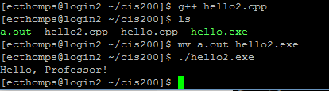

Task 4:

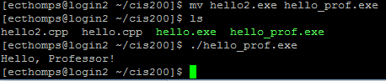

Task 5:

